TERRALINK

PHASE-5

Testing, Performance & Reliability Evaluation

DYNAMIC TERRALINK

Emergency Communication System using LoRa, GPS and Relay-Based Communication

REPORT SCOPE | Functional testing • Performance evaluation • Test cases • Error analysis • Debugging • Power • Reliability • Future improvements
SYSTEM PATH | Trigger → GPS → SOS Packet → LoRa Transmission → Relay → Rescue Station → Status
EVALUATION | ESP32 sender • LoRa mesh forwarding • GPS • OLED status • relay nodes • rescue/base-station receiver

FUNCTIONAL TESTING
Functional testing verifies the complete TerraLink emergency communication sequence from user trigger through final status.

Function | Expected Behaviour | Validation Focus
SOS Trigger | Touch input detects the emergency request. | TTP223 response and wake-up.
GPS | Location is acquired when required. | Latitude and longitude availability.
SOS Packet | Emergency information is assembled. | Node ID, SOS, GPS, battery, packet ID and TTL.
LoRa Transmission | Packet is transmitted through the LoRa link. | Sender transmission.
Relay Forwarding | Valid packet is received and forwarded. | Multi-hop operation.
Rescue Station | Final packet is received. | End-to-end delivery.
OLED / Status | User receives local status information. | Awake / alert transmitted display.

Testing Principle
Each functional block is verified independently and then as part of the complete emergency path. Unsupported numerical results are not fabricated; measured values must come from the physical experiment.

Functional Validation Flow
Touch Input → ESP32 Processing → GPS Data → SOS Packet → LoRa TX → Relay Forwarding → Rescue/Base Station → Status

Expected Outcome
A valid emergency event should be detected, the required packet information assembled, the packet transmitted through the intended LoRa path, and the final receiver should obtain the emergency information.

PERFORMANCE EVALUATION
Performance evaluation measures how effectively TerraLink delivers emergency packets across the LoRa mesh and how quickly the system responds.

Parameter | What is Evaluated | Result / Record
Packet Delivery | Successful packets reaching the receiver. | Record measured value.
End-to-End Delay | Time from SOS generation to final reception. | Record measured value.
Communication Range | Maximum practical communication distance. | Record measured distance.
Multi-Hop Forwarding | Delivery through Relay 1 and Relay 2. | Physical validation.
Duplicate Handling | Behaviour when an existing packet is received again. | Validation result.
GPS Response | Location acquisition time and correctness. | Record measured result.
RSSI / SNR | Signal quality at each communication hop. | Record observed values.

Performance Interpretation
  - High packet delivery ratio indicates that the communication path is functioning consistently.

  - Low and predictable end-to-end delay is important because emergency information must reach the rescue station promptly.
  - Successful multi-hop forwarding demonstrates that TerraLink can extend communication beyond a direct link.
  - Effective duplicate rejection prevents repeated packets from creating repeated alerts or unnecessary forwarding.
  - Fast recovery after a node or link failure improves the availability of the communication network.

TEST CASES — TC-01 TO TC-09
Large-format validation matrix for clear review and physical testing.

ID | TEST CASE | EXPECTED RESULT | STATUS
TC-01 | Power ON / Boot | ESP32 starts correctly and initializes required modules. | Implemented / Validate
TC-02 | SOS Trigger | TTP223 touch activates emergency request. | Physically Test
TC-03 | Deep-Sleep Entry | Node enters low-power state when idle. | Physically Test
TC-04 | Wake from SOS | Touch event wakes the sender from sleep. | Physically Test
TC-05 | OLED Wake Display | OLED shows TerraLink wake/status information. | Physically Test
TC-06 | GPS Acquisition | GPS obtains valid latitude and longitude when required. | Physically Test
TC-07 | SOS Packet Generation | Emergency packet contains required information. | Implemented / Validate
TC-08 | Packet ID Uniqueness | New emergency events use distinct packet IDs. | Validation / Planned
TC-09 | LoRa Transmission | Sender transmits the emergency packet. | Physically Test

3. TEST CASES — TC-10 TO TC-18
Large-format validation matrix for clear review and physical testing.

ID | TEST CASE | EXPECTED RESULT | STATUS
TC-10 | Relay 1 Reception | Receives a valid sender packet. | Physically Test
TC-11 | Relay 1 Forwarding | Forwards valid packet. | Physically Test
TC-12 | Relay 2 Reception | Receives forwarded packet. | Physically Test
TC-13 | Relay 2 Forwarding | Forwards packet to receiver. | Physically Test
TC-14 | Receiver Reception | Base/rescue station receives emergency packet. | Physically Test
TC-15 | End-to-End Alert | SOS reaches rescue station through mesh. | Physically Test
TC-16 | Duplicate Detection | Repeated copies are discarded. | Validation / Planned
TC-17 | TTL Handling | TTL is reduced on forwarding, and expired packets are dropped. | Validation / Planned
TC-18 | Invalid Packet Handling | Malformed/invalid packets are safely rejected. | Validation / Planned

TEST CASES — TC-19 TO TC-25
Large-format validation matrix for clear review and physical testing.

ID | TEST CASE | EXPECTED RESULT | STATUS
TC-19 | RSSI/SNR  Observation | Link quality is observed at each hop. | Physically Test
TC-20 | Weak-Link Behaviour | Behaviour is checked under weak signal. | Validation / Planned
TC-21 | Relay/Link Failure | Communication is checked when the relay/link fails. | Validation / Planned
TC-22 | Repeated SOS Reliability | Repeated emergency events are checked. | Physically Test
TC-23 | Power Consumption | Current/power is compared across states. | Physically Test
TC-24 | Restart Recovery | System operates normally after restart. | Physically Test
TC-25 | Long-Duration Operation | Stable extended operation is checked. | Validation / Planned

ERROR ANALYSIS & 5. DEBUGGING ANALYSIS
The following development issues were identified during TerraLink development and linked to corrective debugging actions.

ERROR / ISSUE | IMPACT | CORRECTIVE ACTION
OLED not turning ON | No local status display. | Check I2C wiring, address, initialisation, and SH1106 configuration.
SOS not sending | Emergency packet was not transmitted. | Verify touch input, wake sequence, LoRa initialisation, and send routine.
GPS lock slow | Location unavailable immediately. | Allow acquisition time and activate GPS only when required.
Deep-sleep components stayed ON | Expected power saving was not achieved. | Control OLED/GPS/LoRa power states and verify sleep configuration.
Touch did not wake | Emergency wake event failed. | Verify wake-capable GPIO and touch signal path.
LoRa receive/forward issue | Mesh delivery was interrupted. | Check frequency, SPI pins, sync word, packet format and forwarding logic.
Duplicate packet issue | Repeated processing/forwarding could occur. | Use packet-ID tracking and duplicate rejection where implemented.

Debugging Method
  - Reproduce the problem and confirm that the error is consistent.
  - Identify the affected module: trigger, GPS, packet processing, LoRa, relay, display or power.
  - Inspect inputs, trace processing with serial/debug messages, and inspect outputs.
  - Apply only the relevant hardware, configuration or software correction.
  - Retest the failed test case and perform regression testing.

POWER CONSUMPTION ANALYSIS
Power analysis evaluates the battery-oriented design of TerraLink. Deep sleep reduces idle activity, while SOS events activate the functions required for emergency communication.

STATE | POWER STRATEGY | MEASUREMENT TO RECORD
Deep Sleep | ESP32 and unnecessary peripherals kept in low-power state. | Sleep current.
Wake / SOS | Required functions become active. | Wake current.
GPS Active | GPS operates when location is required. | GPS current and acquisition duration.
LoRa TX | Radio is active during packet transmission. | TX current and duration.
LoRa RX / Relay | Radio receives and forwards emergency packets. | RX current and duration.
OLED | Used for local status; ideally off during sleep. | Display current.
Battery Operation | Compare duty cycle and operating states. | Estimated runtime from measured data.

Measurement Guidance
Actual current values should be obtained using a suitable current/power measurement instrument. Battery-life figures should be calculated from measured data.
Power calculation: P = V × I, where P is electrical power in watts, V is voltage in volts and I is current in amperes.
Do not use nominal module current values as the final project measurement. Use values measured from the actual TerraLink hardware.

ILLUSTRATION GRAPHS

Supporting visuals for the Phase-5 evaluation

TC-15: End-to-End Delay vs Trial
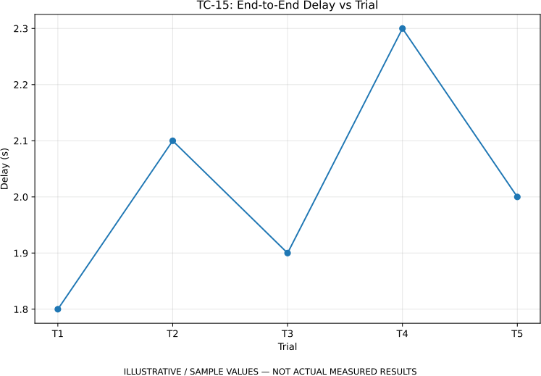

TC-19: RSSI vs Distance
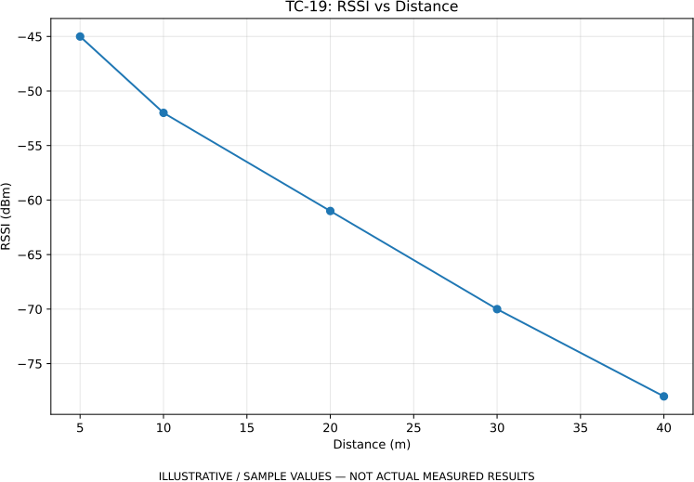

TC-19: SNR vs Distance

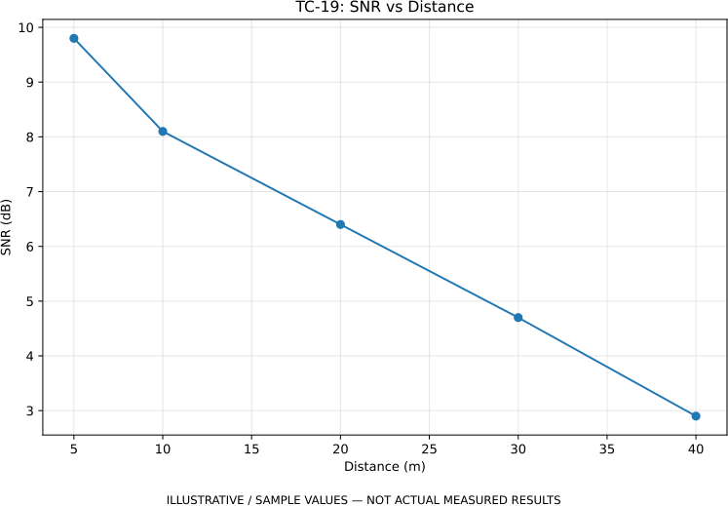

TC-20: Packet Loss vs Distance
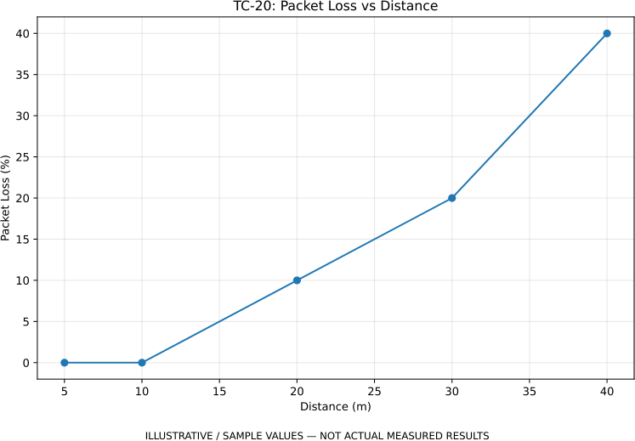

TC-22: SOS Reliability vs Trial Group

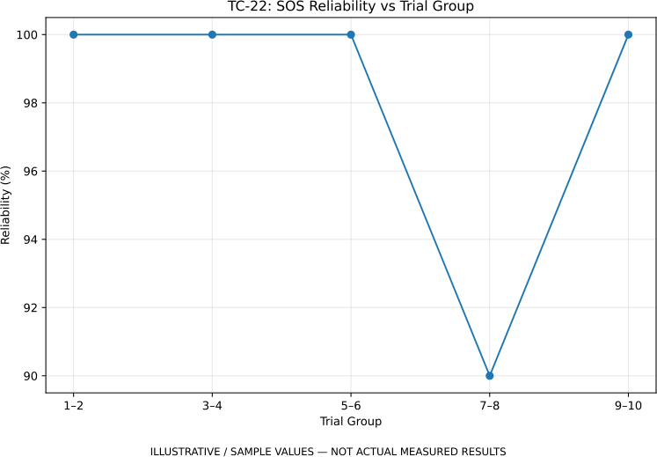

TC-23: Illustrative Power Consumption
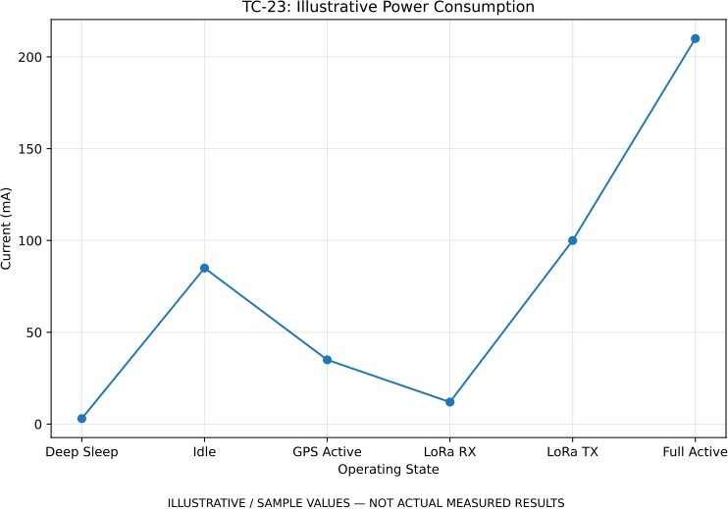

RELIABILITY TESTING & FUTURE IMPROVEMENTS
Reliability testing checks whether TerraLink continues to operate correctly across repeated alerts, multi-hop forwarding, weak links, relay interruptions and restarts.

TEST AREA | RELIABILITY CHECK | ACCEPTANCE FOCUS
Repeated SOS | Send multiple emergency events. | Consistent packet generation and transmission.
Multi-Hop Path | Sender → Relay 1 → Relay 2 → Receiver. | Successful forwarding.
Weak Signal | Observe operation under reduced signal quality. | Graceful communication behaviour.
Relay Interruption | Interrupt a relay or communication link. | Safe handling of the changed path.
Duplicate Packet | Repeat an existing packet. | Duplicate handling.
Restart Recovery | Restart the node after operation. | Normal recovery.
Long Duration | Operate for an extended period. | Stable operation without unexpected failure.

Future Improvements
  - Dynamic relay selection: deploy portable relay nodes where additional coverage is required.
  - Adaptive routing: use link quality, hop count, battery level and reliability for route selection.
  - Acknowledgement mechanism: provide stronger confirmation that the emergency packet reached the rescue station.
  - Improved duplicate handling: maintain packet history to prevent repeated processing.
  - Battery optimization: further reduce idle consumption and optimize GPS/LoRa activation.
  - Expanded reliability testing: validate weak links, relay failure and longer operating periods.
  - Data logging: record RSSI, SNR, delay, delivery and power measurements for quantitative evaluation.

Reliability objective
- To develop a LoRa-based emergency communication system for areas where conventional communication networks are unavailable.
- To transmit SOS alerts from a user device to a rescue/base station through LoRa communication.
- To obtain and transmit GPS location along with the emergency alert for identifying the affected person's location.
- To use relay nodes to extend communication coverage through multi-hop communication.

Conclusion
TerraLink integrates SOS triggering, GPS location information, low-power ESP32 operation and relay-based LoRa multi-hop communication for emergency communication. The Phase-5 test plan covers functional behaviour, performance, error correction, power consumption and reliability.

PCOMPLETION STATEMENT
This report presents a structured evaluation framework for the TerraLink prototype, documenting what was implemented, what was tested, the issues encountered, the corrective debugging approach, the reliability checks and the next engineering improvements.

